Couples Weekend - Celebrate Valentine’s Day

Getting to the Heart of the Matter

Led by: Dan Wile, PhD and Dorothy Kaufmann, MFT

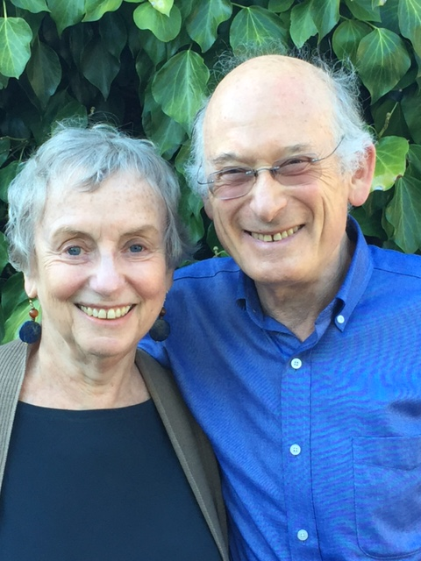

February 3 & 4th, 2018 –San Diego, CA

A weekend workshop for couples, co-led by Dan Wile and Dorothy Kaufmann, will be offered for the first time in San Diego, California.
This workshop will provide tools developed over the 40 years of Collaborative Couple Therapy, created by Dan, about how to have an engaged and fulfilling relationship. The heart of the weekend is experiential exercises done privately with your partner. Dan, Dorothy, and Laara Israhel, LMFT, help each couple as needed. This is a LGBTQ friendly workshop.

Workshop Summary
In addition to whatever specific issues a couple is struggling with (money, sex, children), there is generally the added and often more significant problem of how they talk--or don’t talk-- about these issues.
The quality of life in a relationship depends on our ability to recover from the inevitable periods of fighting or withdrawing; that is, from turning each other into enemies or strangers. At a minimum, we want to keep such fighting and withdrawing from destroying the relationship. But it is possible to turn these hazards into means for deepening the relationship by holding a recovery conversation, in which both partners are able to say what they feel in a way the other can hear.
In such a conversation, couples are in position to remember what they cherish about each other and to come up with whatever solutions, agreements, compromises, understandings, or meetings-of-the-mind might be possible.
In an optimally functioning couple, fighting and withdrawing become opportunities for intimacy. In this workshop, we show how to create a reservoir of good will and a perspective from which partners can jointly guide the relationship.

Workshop Leaders:
Daniel Wile, PhD, is a couple therapist in private practice in Oakland, CA. He has published numerous articles and three books (Couples Therapy, After the Honeymoon, and After the Fight) on couples in relationship. Dan gives professional workshops nationally and internationally.
Dorothy Kaufmann, PhD literature, MFT, has a private practice in Oakland, CA, working with couples and individuals. In her previous life in higher education, she taught and wrote in the humanities, a career she sees as informing her present vocation.
Dan and Dorothy also provide therapy conjointly, seeing couples who would like to work with a couple.
Organizer and contact, Laara Israhel, LMFT, is in private practice in San Diego. She works with couples, individuals and families. Laara brings a long history in Mindfulness to her work with couples and individuals.
Comments by past participants:
- I found that every private session (10 minutes or more of couples only conversation) yielded something new about my partner that I didn’t know before. And this enhanced my curiosity about and empathy for him. I also learned new things about myself and was reminded of other important things about us as a couple.
- The Sunday afternoon recovery conversation and the gentle, curious questions and supportive inquiring to expand on the experience were wonderful. I loved the positive “reservoir of good will” building and the Recovery Conversations.
- It was a huge beautiful turning point for both of us.
- Especially useful was hearing about how Dan and Dorothy navigate their own struggles.
- The tone and rhythm of Dorothy and Dan was very comforting and created a sense of safety.
- Amazing!! Best workshop I’ve ever attended. Well-paced, great exercises, expert facilitators.

Workshop Information:

Location: San Diego Psychoanalytic Center
4455 Morena Boulevard, suite 202 (near Pacific Beach next to the Rose Canyon Costco)
San Diego, California 92117
Fee: $795.00 per couple, $845.00 if received after January 1, 2018. Workshop space is limited. Early registration is recommended. Workshop is limited to 9 couples.
Time: 9:30am to 4:30pm, both Saturday and Sunday
Lunch and snack will be provided

REGISTRATION
Dan Wile & Dorothy Kaufmann

COUPLES WORKSHOP - Celebrate Valentine’s Day Weekend – Getting to the Heart of the Matter

Please type or print clearly
Names: ______________________________ _______________________________
Phones: _____________________________ _______________________________
Emails ______________________________ _______________________________
Address _________________________________________City____________________
State ________________ Zip __________
Second address if living separately _________________________________________
How did you hear about our workshop? _____________________________________

Anything else you’d like us to know:
This workshop offers 12 CE units for California psychologists, LCSWs and MFTs, LPCC’s. Collaborative Couple Therapy Seminars is approved by the California Psychological Association (CPA) to provide continuing professional education for psychologists. The California Board of Behavioral Sciences (BBS) now accepts CPA continuing education credit for license renewal for LCSWs and MFTs and LPCCs.
For CE units:
Name __________________ License type__________ License#__________ State ____

Mail registration form with a check for $795.00 ($845.00 after January 1, 2018) to:

Laara Israhel, LMFT, 619-804-8747

2831 Camino del Rio S, ste 112

San Diego, California 92108

www.relationshipsandiego.com

